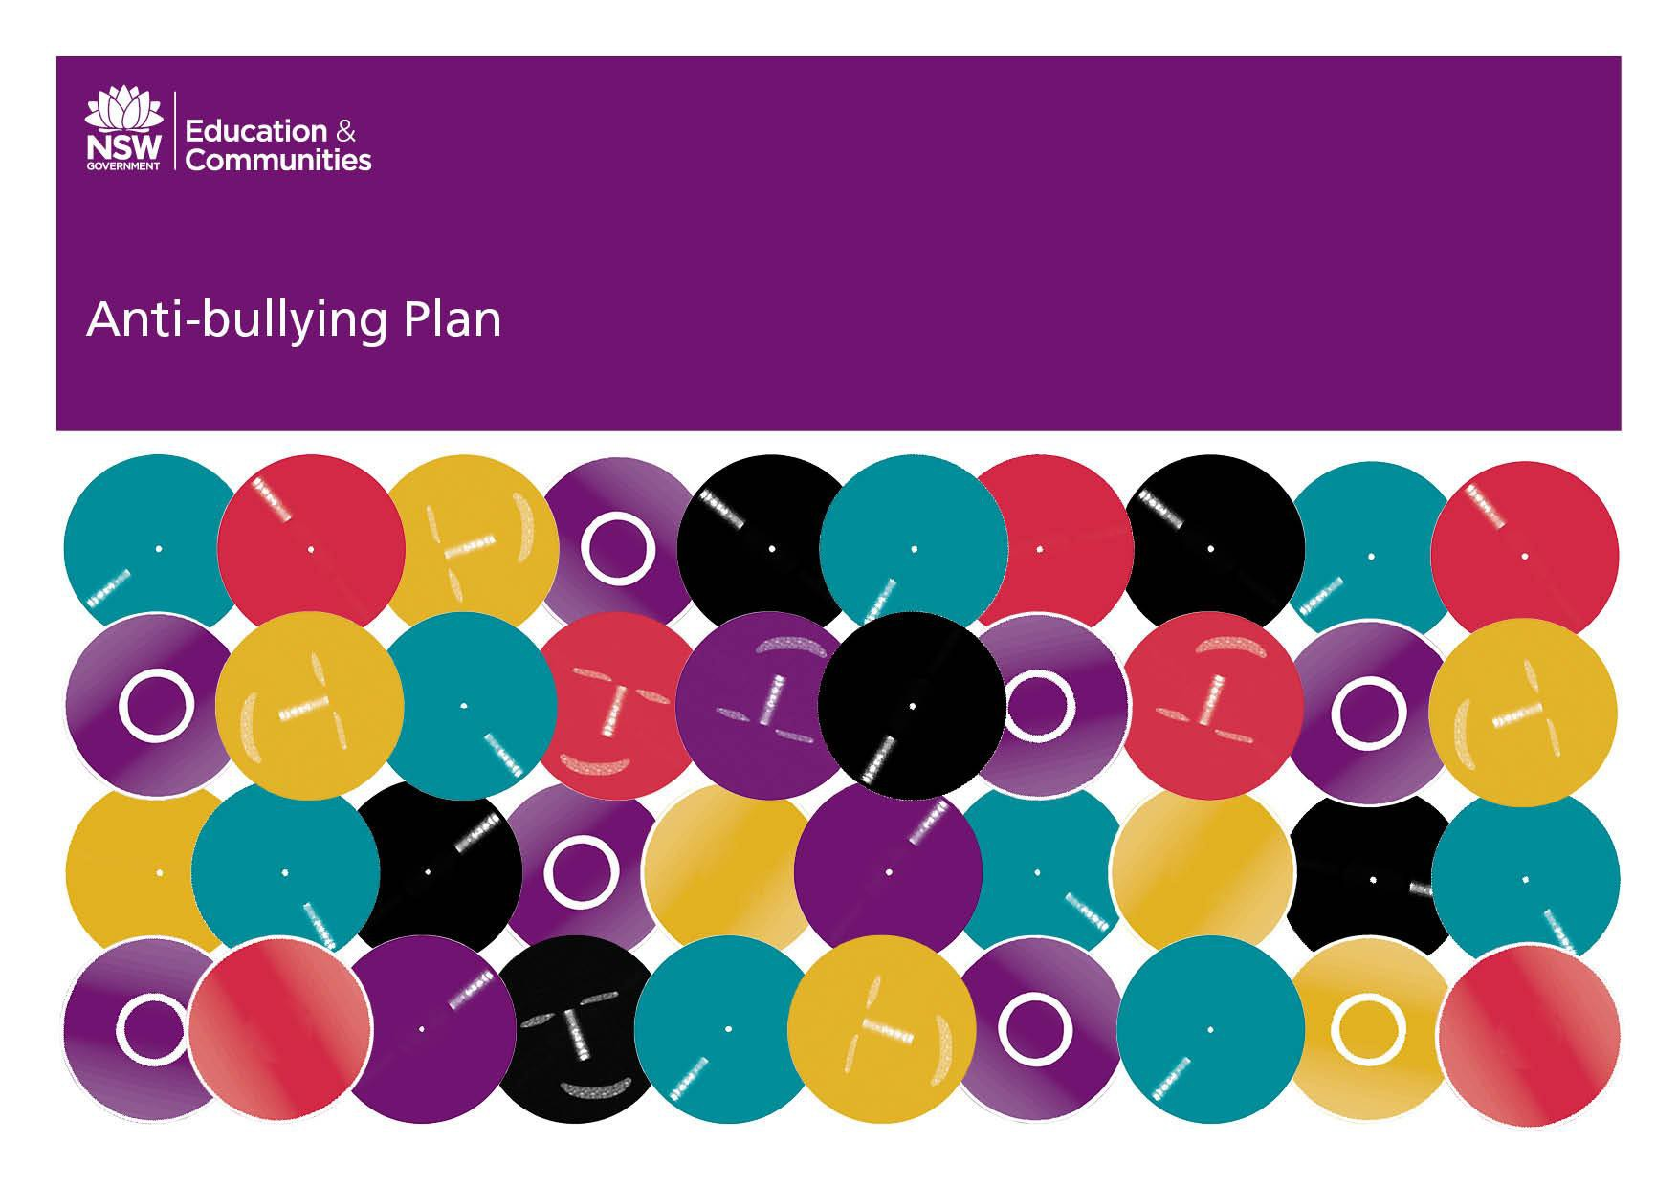

Wooli Public School (DRAFT 2018)

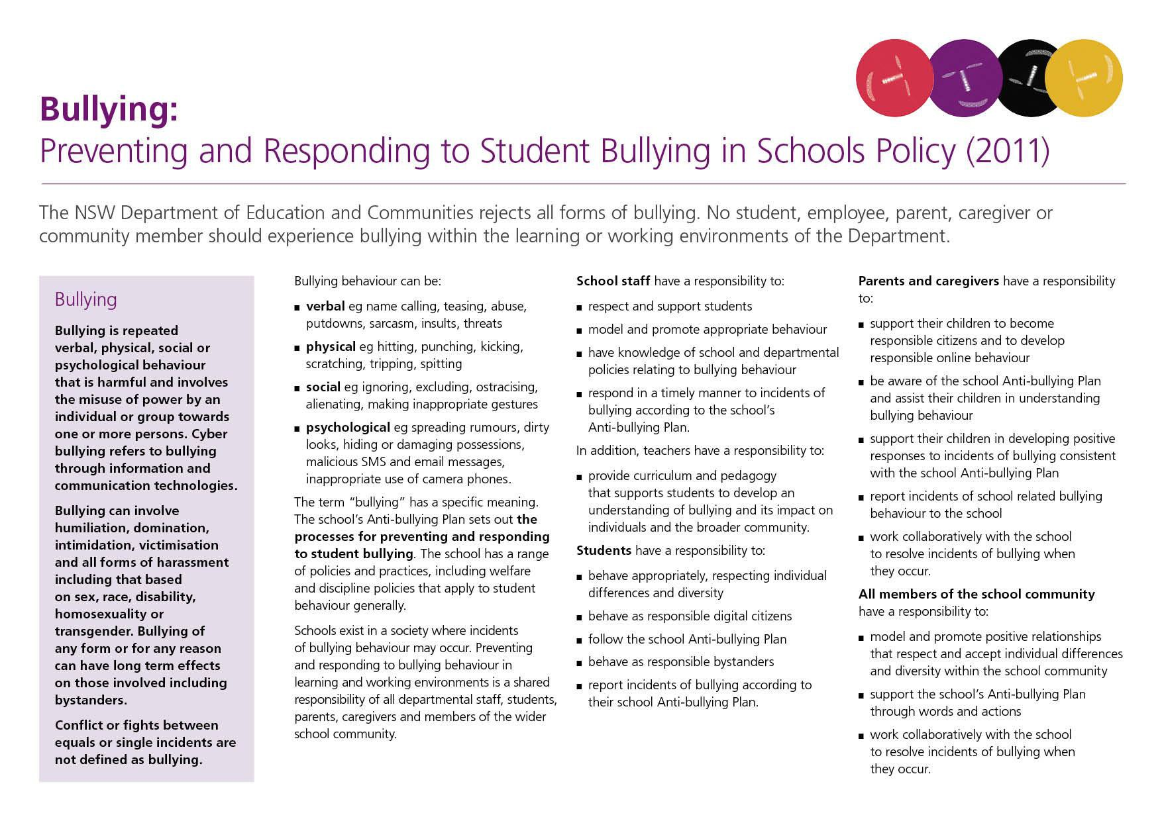
TOurhe Anti-SBulchoollying PlanAnt– NSWi-DBullepartmenyint ofgEduPcalantion and Communities

Our School Anti-Bullying Plan
This plan outlines the processes for preventing and responding to student bullying in our school and reflects the Bullying: Preventing and Responding to Student Bullying in Schools Policy of the New South Wales Department of Education and Communities.
Representation from parents, students and staff on the development of this plan was ensured through student surveys on bullying behaviour, parent discussions at P and C meetings and evaluation of school data by staff in 2011. The whole school community will continue to implement the plan with ongoing annual evaluation and review

Statement of purpose

Our school community is committed to providing a safe and secure environment promoting personal growth and excellence by developing confidence and self esteem.

Protection
Wooli Public School and the community affirms the rights of all members of the school community to feel safe and be safe at school.
We acknowledge that being safe and supported at school is essential for student wellbeing and effective learning.
We accept responsibility for developing and sustaining safe and supportive learning and teaching environments.
Our school encourages the active participation of all school community members in developing and maintaining a safe school community where diversity is valued
The school and community actively support young people to develop understanding and skills to keep themselves and others safe

Bullying is the intentional harming or hurting of a person, or their belongings, by another person or persons that causes distress, hurt or undue pressure.

Bullying is taken seriously and not acceptable in any form including cyberbullying. (Bullying through information communication technologies)
The school is committed to developing a safe school community through a whole-school and evidence-based approach
A whole school education program will be implemented each year to develop the students understanding of bullying and its impact on others.

Prevention
Strategies and programs the school will implement for bullying prevention.
- Wooli Public School will maintain a positive, welcoming, co- operative and fair culture of respectful relationships where bullying is less likely to occur.
- Teachers and staff will model and promote explicit pro-social values and expectations for behaviour (eg tolerance, respect, inclusiveness, co-operation)
- The school will promote positive, caring and respectful student-peer relationships, student- teacher relationships and teacher – teacher relationships.
- Consistent handling of issues by staff to assist students to understand the procedures and expectations of positive behaviour. Explicit communication and teaching at assemblies, in class and with individuals

The school embeds anti-bullying messages into each curriculum area and in every year level through:
- A social skills and positive behaviour program, “Keys to Effective learning and Behaviour.” This is implemented cross K-6 every year, through literacy, PD/H/PE and HSIE.
- Anti – bullying lessons are dealt with in child protection lessons and as the need arises in the form of discussions with individual children, small groups or whole school.
- Cyberbullying is taught in stage 2 and 3 using the Cybersmart Kids Program.
- Teachers have anti bullying messages on their uniforms.
- Anti Bullying videos are produced/ shared in Stage 3 as part of Cini-literacy initiative.
Social Skills Programs based on students ages:

- Problem Solving and Tolerance
- Being a good friend
- Being a team player
- Joining in a game
- Co-operation and communication games
- Conflict resolution
- I statements

Early Intervention
Early intervention strategies and programs for students who are identified as being at risk of developing long-term difficulties with social relationships and those students who are identified at or after enrolment as having previously experienced bullying or engaged in bullying behaviour.

- The staff will identify students and provide support when a child has been affected by, engaged in, or witnessed bullying behaviour. This includes follow up discussions and development of appropriate strategies.
- Parents will be notified. Parents and staff will collaboratively develop an intervention plan to support students and to develop positive skills.
- Early intervention strategies will be provided through peer support, close monitoring of student relationships, the nurturing of positive friendships and one on one conferencing with staff.
- Positive Rewards given to students for exhibiting Positive Playground Behaviour based on Keys to effective Learning and Behaviour. Reward system each term and end of Year.
- School Counsellor intervention may also be required.

Response
Strategies to empower the whole school community to recognise and respond appropriately to bullying, harassment and victimisation and behave as responsible bystanders.
- Victims and witnesses are encouraged to immediately inform a teacher. All issues are followed up by teachers and if necessary, refer the issue on to the Principal.
- Parents are encouraged to inform the school of any bullying or harassment incidents that may be causing anxiety or a change in behavior with their child. Parents and staff will work together to implement strategies to support the child.
- Social media problems can be reduced when the school and parents work together. Generally primary age students are not mature enough to cope with social media without guidance and regular monitoring.
- Parents are made aware that it is illegal to have a ‘Facebook’ account under the age of thirteen. Our parents are strongly encouraged to monitor their children’s social media usage, e.g. SMS and email usage in order to promote being cybersmart and prevent cyberbullying.
- Cyberbullying is treated in the same manner as any other form of bullying at Wooli Public School when there is a direct link between

the school and the offender. This relationship can be linked because the students attend the school.
Tips/Code of Behaviour for preventing Cyberbullying include:

- Never post pictures or videos of someone without their permission.
- It is illegal to have a ‘Facebook’ account under the age of thirteen.
- Never communicate anything bad or negative about someone using the internet or mobile phone.
- If you discover others sharing nasty comments about someone online then keep a copy and show it to an adult or teacher to stop the bullying.
- Never join in.
- Be cybersmart.

Procedures for reporting incidents of bullying at Wooli Public School.
Action taken by the school includes:
  - When a child reports an incident or is seen to be bullied a teacher or Principal conducts an informal meeting to ascertain facts
  - The student who bullied fills out a Behaviour incident Form. ( as per Discipline Policy)
  - The incident is recorded in SENTRAL. This allows for monitoring of patterns and trends in bullying.
  - Parents are contacted and discussed deemed necessary.
  - Students may be placed on detention withdrawn from play.
  - School computer privileges are suspended.
  - Provide a formal written caution detailing inappropriate behaviours, as well as clear expectations of what is required of the student in the future,
  - If the offence warrants it, school suspension can be issued.
  - Bullying or cyberbullying that appears to involve criminal behaviour such as violence, threats, intimidation, inciting violence, hacking will be reported to the police and to the School Safety and Response Unit Hotline on 1300 363 778.
  - Develop, in conjunction with the school learning support team or appropriate school or departmental personnel, a specific behavior management plan to assist the student to manage inappropriate behavior, if required.
  - record all action taken.

Details of these procedures are published in School Newsletters and the School Information Book given to all new families.
Procedures and timeframes when an incident of bullying is reported to the school.
- Staff or Principal will conduct interviews to gain facts on the incident.
- Logical consequences will be given to offenders as per procedures.
- Follow up de-briefing with student who has been bullied.
- Report back to parent who reported the incident within 24 hours.
- Parents of offender will be informed if required.

Processes to match interventions to the particular incident of bullying.

SEVERITY SCALE

- Teasing – sometimes mistakenly called playful
- Malicious, Sustained – often name calling, ignoring, dirty looks, exclusion, putdowns, stealing, spreading rumours, inappropriate gestures
- Pre-meditated / violent – hitting, pushing, damage to property or persons.

CONSEQUENCES

Severity 1. Procedural steps followed. Name placed in Playground Behaviour Book and counted towards a Behaviour Level. Student off playground that session.
Severity 2. Procedural steps followed. Name placed in Playground Behaviour Book and counted towards a Behaviour Level. Student off

playground for one day or more. Teacher conducts meeting with all involved.
Severity 3. Procedural steps followed. In school suspension or suspension. Letter home. Parent meeting.
- empower the whole school to recognise and respond appropriately to bullying.
- Major incidents of bullying will be reported in the school newsletter in line with Department of Education and Communities and Legal Branch Policy.

Strategies and programs implemented to support any student who has been affected by, engaged in or witnessed bullying behaviour.
No, Go, Tell Strategy

- Stay in sight of peers and adults.
- Try to stay calm. Practice keeping calm and walking away.
- Try to show you are not upset. Practice this.
- Look at the person. Try to speak in a strong voice. Say something like “You might think that but I don’t” or “Why are you doing this?”
- Use an “I” message. Express your feelings in an assertive way e.g. “I want you to stop” or “Please don’t do that, I don’t like it”.
- Walk away quietly without looking back.
- Go to a safe place e.g. with other children; near a teacher
- Talk to a teacher or someone who can help you. Tell them what has happened, how you feel and what they can do to help. This is not “dobbing”!
- Furthers strategies may include:
- Resilience Training through School Counsellor.
- Social skills training for offenders and victims.
- Conflict resolution strategies.
Explain the school’s procedures for reporting incidents involving assaults, threats, intimidation or harassment to the police.
- Incident referred to Principal.
- Principal obtains facts from staff / students and ascertains whether incident warrants reporting to Police.
- Factors to consider include:
  - Visible injury eg bruised face, split lip or swelling
  - Pain or discomfort
  - Ambulance required
  - Premeditated or planned incident
  - Incident recorded and posted on social networking site
  - Sustained impact on the school or its community eg EAPS services required
  - Affected school routines or operations.
  - History of aggression or history of this conflict in the community
  - Weapons involved
  - Staff, parent or carer request notification to Police regardless of your intention.
- Incident reported to the Police and to the School Safety and Response Unit Hotline on 1300 363 778
- School Education Director informed.

Explain the school’s plans for providing regular updates, within the bounds of privacy legislation, to parents and caregivers about the management of bullying incidents that have been reported to the school.
- Parents will be informed through the newsletter of how this Policy overlaps the School behavior and Discipline policy and procedures, to

Explain the procedures the school will use with regard to contacting the Child Wellbeing Unit or Community Services where appropriate.
- Principal to contact the Child Well Being Unit or the Child Protection Helpline if the incident gives rise to a requirement to make a mandatory report.
Departmental appeal procedures and provide information about the Complaints Handling Policy.
Complaints Handling Policy
The NSW Department of Education (DOE) seeks to resolve difficulties, grievances and complaints in a prompt, impartial and just manner
- It is best to discuss your concerns with your child's teacher first. Make an appropriate time to meet with them or phone the school and ask for an appointment with the teacher.
- If you are not happy with the result, or if you do not feel it is appropriate to talk to them, phone and make an appointment to discuss your concerns with the principal.
- You may bring a friend or relative to be your support. If you need an interpreter, we can arrange that - just ask beforehand.
- If your complaint is about the principal you will need to contact the school education director in your area. Ask the school office staff at your school for their name and number.
- If your complaint cannot be resolved in an informal way, we may ask you to put it in writing. It is important that you include specific details of the situation and tell us what you would like to happen as a result of your complaint
- Alternatively a complaint form may also be used. Complete the form and send it to the principal, or the school education director in your area.

Appeals
- Appeals can be made to the school education director about the imposition of a suspension from a particular school.
- The school education director may delegate the management of an appeal to an appropriate officer such as the student services officer.
- In all cases, however, the school education director must make the determination.
The school education director will:
- deal with the appeal within 20 school days of its lodgement
- ensure that communication lines are maintained with the person(s) making the appeal and that they are kept aware of the progress of the appeal
- review all relevant material
- ensure that appropriate material has been made available to the student and his or her parents
- discuss relevant issues with the person(s) making the appeal and any other parties, as appropriate
- advise all the parties of the decision and the specific reasons for reaching the decision.
Detail the strategies the school will use to identify patterns of bullying behaviour. Explain how the school will respond to such patterns.
- Bullying will be discussed with students on a regular basis
- Programs will be implemented to respond to patterns eg social skill of co-operation taught if high incidence of bullying found during games at lunch

This Anti-bullying Plan will be made widely available to the school community through:
- School Newsletter.
- Posted on Website.
- Sent home to parents.

Monitoring and evaluating the effectiveness of this Anti-bullying Plan.
Monitoring of the severity, frequency and duration of bullying incidents will occur each term during staff meetings, when reviewing Behaviour and Student Welfare programs.

Reporting annually to the school community on the effectiveness of the Anti-bullying Plan.
Through School Newsletters, P and C Meetings and ASR.

Explain how and when (at least every three years) your school will review this Anti-bullying Plan with the school community.
The success of the plan will be determined through parent, teacher, student surveys, analysis of school data and staff feedback. The school and community will review and refine the plan as required.

Next review date will be 2021

Additional Information
Kids Help Line: 1800 55 1800 or www.kidshelp.com.au/kids/

Principal’s comment
Anti-bullying policy was develop by
Mrs R Parnell - Principal
Mrs R Essex- Teacher Miss B Roberts- Teacher
Mr J Trevillian- Chaplain
Mrs G Armstrong-Parent

School contact information
Wooli Public School
Main Street, Wooli, 2462
Ph: 66497522
Email: Wooli-p.school@det.nsw.edu.au

Web: www.Wooli-p.school@det.nsw.edu.au

